There are total 3 Erangle matches with 30 min of break.

All duo matches.

Team with maximum points will win.

If two teams have same points then team with maximum placement point will win.

If two teams have same kill and Placement point then the team that survived more will win.

There is one point for every kill and Placement point are given as :-

|  |  |
| --- | --- |
| **RANK** | POINTS |
| #1 | 15 |
| #2 | 12 |
| #3 | 10 |
| #4 - #5 | 8 |
| #6 | 6 |
| #7 | 4 |
| #8 - #12 | 2 |
| #13 - #16 | 1 |

PLACEMENT TABLE

After each match leader of the team take immediate screenshot after both team member are finished and there match stats and send into whatsapp group

Like:- 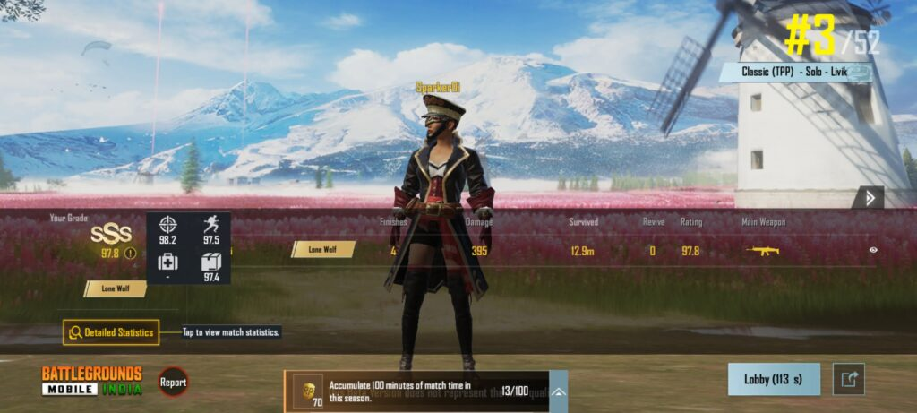

Info. About match:-

Lobby of 50 teams(100 players)

Any weapon allowed.

Zone speed is 1x.

Default supply.